**FORM FOUR 231/3 END TERM ONE YEAR 2025**

1. You are provided with a specimen labeled K and hydrogen peroxide

(a) (i) What part of plant is specimen K? (1mk)

………………………………………………………………………………………….

………………………………………………………………………………………….

(ii) Give a reason for your answer in a (i) above

(1mk)

…………………………………………………………………………………………….

…………………………………………………………………………………………….

(b) Cut three equal cubes whose sides are about 1cm from specimen K. place one of the cubes in a boiling tube labeled A; boil the second cube for about 15 minutes and then place it into a boiling tube labeled B; Cut the third cube into small pieces and place the pieces in a boiling tube labeled C. To each boiling tube add 5mls of hydrogen peroxide .

(i) Record your observations in the table below (3mks)

|  |
| --- |
| Tube Observations |
| A |
| B |
| C |

(ii) Account for your observations in tubes B and C (2mks)

B……………………………………………………………………………………………………

………………………………………………………………………………………………………

……………………………………………………………………………………………………

C (2mks)

………………………………………………………………………………………………………

………………………………………………………………………………………………………

………………………………………………………………………………………………………

………………………………………………………………………………………………………

(c) (i) Write a chemical equation for the reaction that occurs in test tube A (1mk)

………………………………………………………………………………………………………………………………………………………………………………………………………………

(ii) What is the significance of the reaction to living organisms

(1mk)

………………………………………………………………………………………………………………………………………………………………………………………………………………………………………………………………………………………………………………………

(iii) Name the organ in mammals where the above reaction occurs at the highest rate

(1mk)

2. Study the organisms drawn below and answer the questions that follow.

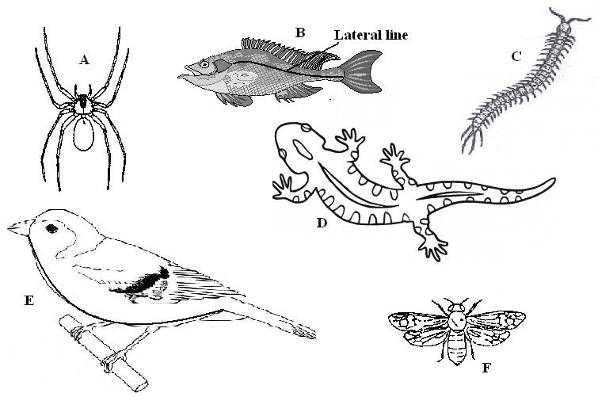

1. Use the dichotomous key below to identify the class the organisms belong to. (12 **marks**)
2. (a) Phylum Chordata go to 2
   1. Phylum Arthropoda go to 3
3. (a) Has scales on the body go to 4
   1. Has no scales on the body Mammalia
4. (a) Has cephalothorax Arachnida
   1. Has no cephalothorax go to 5
5. (a) Has fins Pisces
   1. Has no fins go to 7
6. (a) Has three pairs of legs Insecta
   1. Has more than three pairs of legs go to 6
7. (a) Two pairs of legs per segment Diplopoda
   1. One pairs of legs per segment Chilopoda
8. (a) Has feathers Aves
   1. Has no feathers go to 8
9. (a) Has a tail Reptilia
   1. Has no tail Amphibia

|  |  |  |
| --- | --- | --- |
| Specimen | Step followed | Identity |
| A |  |  |
| B |  |  |
| C |  |  |
| D |  |  |
| E |  |  |
| F |  |  |

1. Name the type of reproduction shown by specimen B and state it disadvantage. (2**marks**)

……………………………………………………………………………………………

………………………………………………………………………………………………………………………………………………………………………………………………………………………………………………………………………………………………………………………………………………………………………………………………………………………………………………………………………………………………………………………………………………………………………………………………………………………………

C) Name three distinct characteristics of the Phylum to which organism F above belongs to (3marks)

…………………………………………………………………………………………

…………………………………………………………………………………………

………………………………………………………………………………………..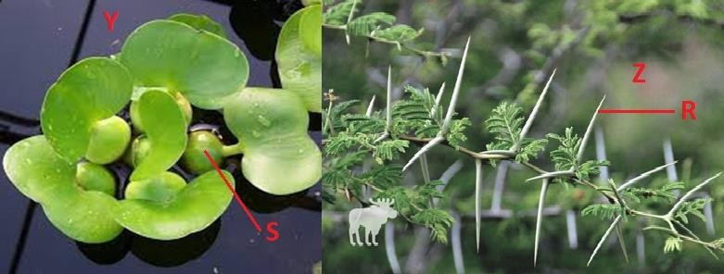

1. Study the photographs below depicting plants growing in different habitats. Use them to answer the questions that follow.

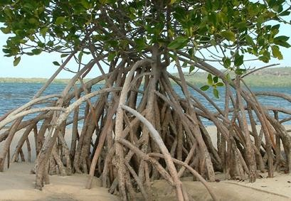

(a) Identify the habitats in which they are found. (3 marks)

**Y**……………………………………………………………………………………………

**Z**……………………………………………………………………………………

T……………………………………………………………………………………..

1. State the significance of the following structures found in the specimens shown above. (2 marks)

**R** ………………………………………………………………………………………………

……………………………………………………………………………………………

**S** ………………………………………………………………………………………………

……………………………………………………………………………………………..

1. State three structural adaptations expected in the leaf of specimen Z. (3 marks)

…………………………………………………………………………………………………………………………………………

………………………………………………………………………………………………………………………………………….

1. State one observable adaptation in specimen for the habitat in which it is found. (1 mark)

…………………………………………………………………………………………………………………

…………………………………………………………………………………………………………………

1. Explain the effect of releasing too much waste containing fertilizer nutrients. ( 2 marks)

………………………………………………………………………………………………………………………………………….

………………………………………………………………………………………………………………………………………….

………………………………………………………………………………………………………………………………………….